The Rockville Film Society
Meeting Agenda
Date: August 13, 2026
Time: 6:00 PM
Location: Rockville Public Library (Peck Conference Room)

1. Welcome

2. What is RFS?

3. What Have You Seen Lately?

4. RPL Display Conversation

5. RPL Public Screenings Conversation

6. Jeopardy! Movie Edition Round 2

7. Closing

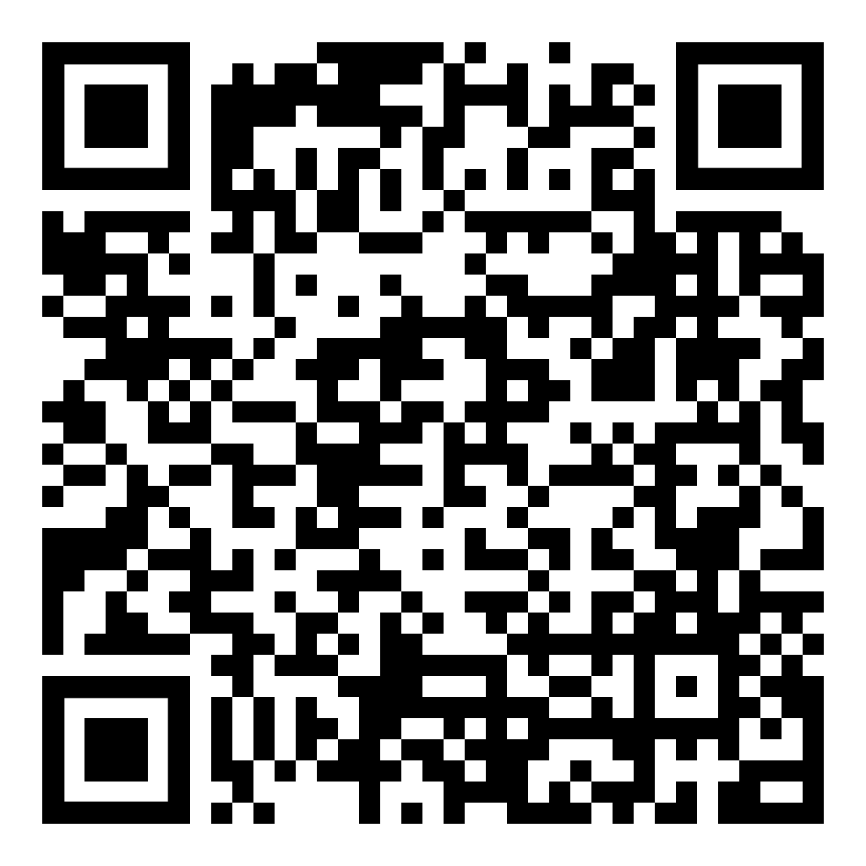
September 2026
Release Calendar

